Axillary artery
Artery of axilla
Continuation of subclavian artery
Continues as brachial artery
Extent: from outer border of first rib to lower border of teres major
Along with axillary vein it is very closely related to cords of brachial plexus
[TIP]Based on relations to axillary artery – cords of brachial plexus are named
[CLINICAL]Axillary artery and brachial plexus wrapped in axillary sheath

Course
- Enters axilla at apex
- Runs in medial wall
- In lower level – related to lateral wall

Parts or subdivisions
- By Pectoralis minor
- Crosses anteriorly
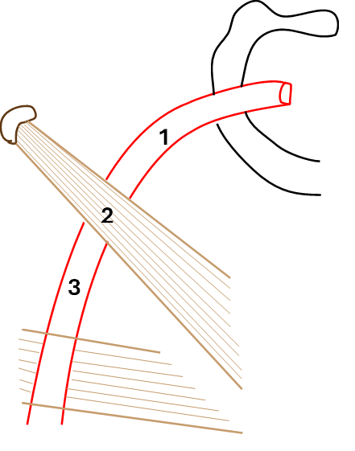

[TIP]Learn to draw the diagram
[YOUTUBE] https://youtu.be/bB6VFBg4CHw

Relations

First part relations
- Lateral cord and posterior cord are lateral to the artery
- Medial cord is posterior
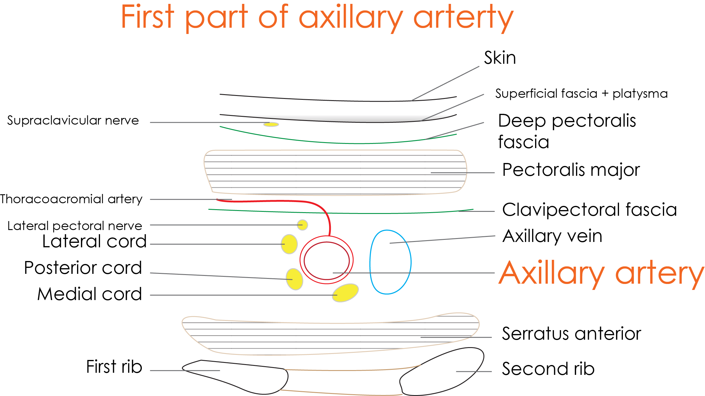

Second part
Second part relations
- Lateral cord is lateral
- Medial cord is medial
- Posterior cord is posterior
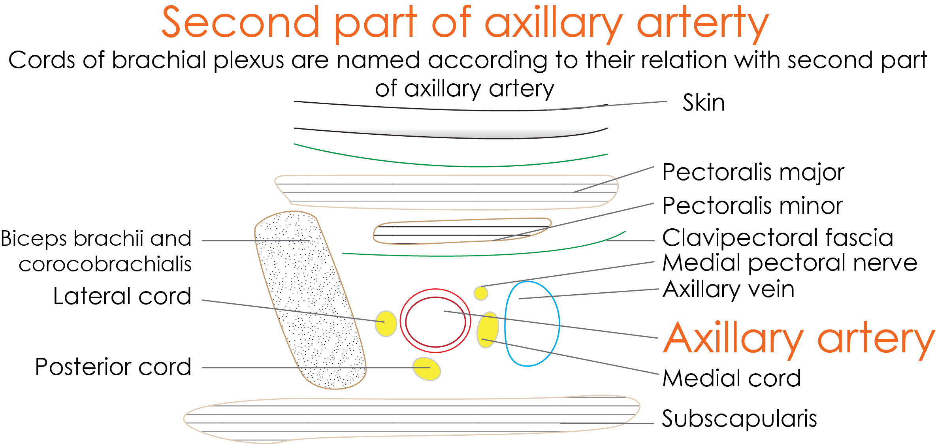

Third part
Third part relations
- Medial - Median root of median nerve, medial cutaneous nerves of arm and forearm
- Lateral - lateral root of median nerve and musculocutaneous nerve
- Posterior - Radial nerve and ulnar nerve
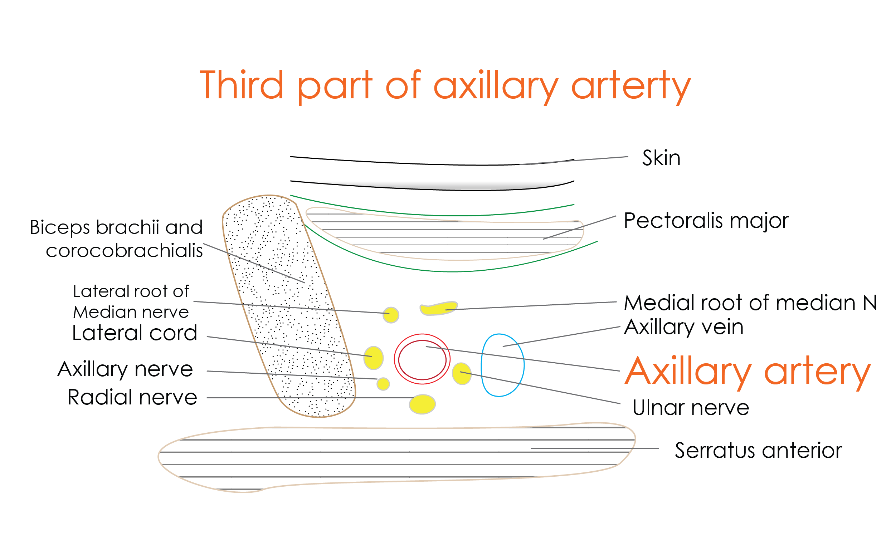

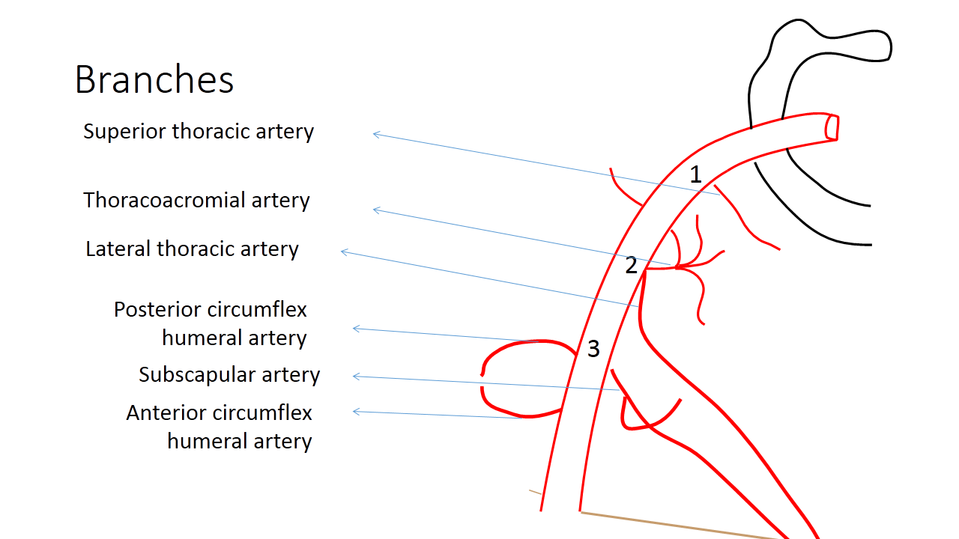
[TIP]Learn to draw diagram
[YOUTUBE] https://youtu.be/LLe-NiXMFJA

Surface marking
With arm in 90 degree abduction -
- Mark the midpoint of clavicle
- Mark the junction of anterior 1/3rd and posterior 2/3rd of lateral wall of axilla at the lower limit
- A line joining these two lines - is axillary artery

Applied aspects
- Axillary pulse can be felt against humerus
- Anuerysm of axillary artery
  - Presents with pulsatile swelling in axilla
  - Compresses branches of brachial plexus
- Through cervicoaxillary canal – infections of spine can spread to axilla
- In case of obstructed distal part of subclavian artery or proximal part of axillary artery – blood can reach distal upper limb via scapular anastomoses

Axillary vein

Axillary vein extent
Formation - union of two brachial veins and basilic vein
Continues as - subclavian vein beyond outer border of first rib

Axillary vein – tributaries
Cephalic vein - after passing through deltopectoral groove, cephalic vein pierces clavipectoral fascia and enters axillary vein
Other tributaries correspond to branches of axillary artery
- Thoracoacromial vein
- Lateral thoracic vein
- Subscapular vein
- Anterior and posterior circumflex humeral vein
___MCQ_START___
Q1. The axillary artery begins at which anatomical landmark?
A. Lower border of teres major
B. Upper border of teres major
C. Lateral border of first rib [CORRECT]
D. Medial border of coracobrachialis
___
Q2. The axillary artery is divided into three parts based on its relation to which muscle?
A. Pectoralis minor [CORRECT]
B. Pectoralis major
C. Subclavius
D. Serratus anterior
___
Q3. Which branch arises from the second part of the axillary artery?
A. Superior thoracic artery
B. Thoracoacromial artery [CORRECT]
C. Subscapular artery
D. Posterior circumflex humeral artery
___
Q4. The largest branch of the axillary artery is the:
A. Lateral thoracic artery
B. Thoracoacromial artery
C. Anterior circumflex humeral artery
D. Subscapular artery [CORRECT]
___
Q5. The axillary vein is formed by the union of which veins?
A. Basilic vein and cephalic vein
B. Basilic vein and brachial veins [CORRECT]
C. Cephalic vein and brachial veins
D. Median cubital vein and basilic vein
___
Q6. The axillary vein becomes the subclavian vein at the level of the:
A. Medial border of first rib
B. Lateral border of first rib [CORRECT]
C. Upper border of scapula
D. Lower border of clavicle
___
___MCQ_END___

